ip route
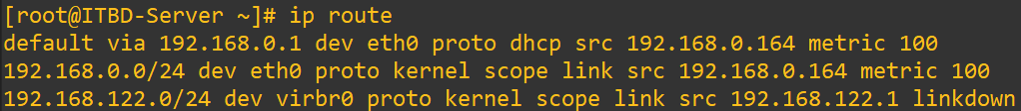
ip -6 route
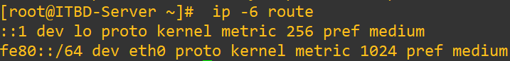
tracepath access.redhat.com
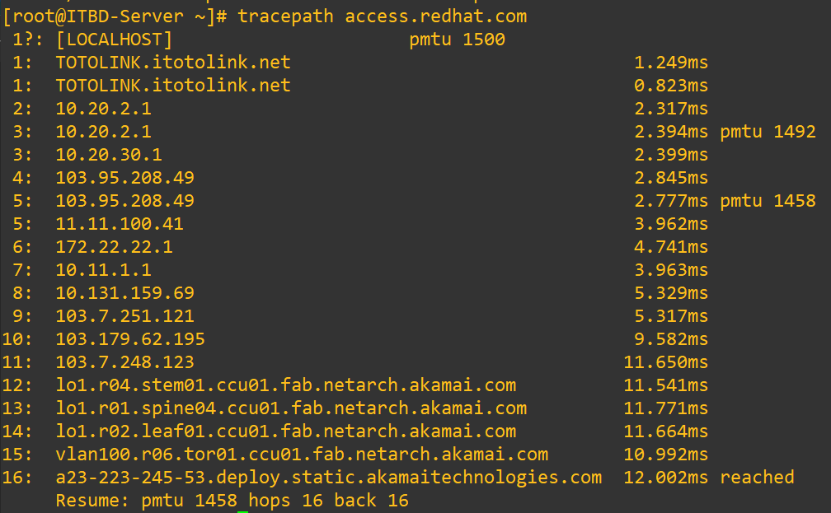
tracepath6 2001:db8:0:2::451

TROUBLESHOOTING PORTS AND SERVICES TCP
services use sockets as end points for communication and are made up of an IP address, protocol, and port number. Services typically listen on standard ports while clients use a random available port. Well-known names for standard ports are listed in the /etc/services file.
The ss command is used to display socket statistics. The ss command is meant to replace the older tool netstat, part of the net-tools package, which may be more familiar to some system administrators but which is not always installed.
[user@host ~]$ ss -ta

nmcli device status
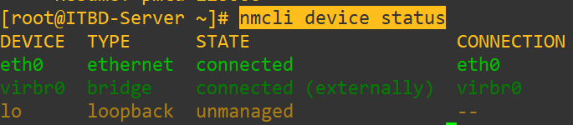

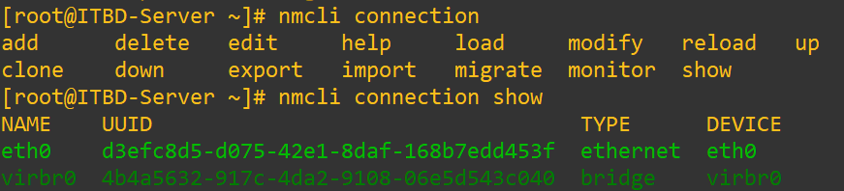

nmcli connection add type ethernet con-name static ifname eth0 ipv4.addresses 10.1.1.10/24 ipv4.gateway 10.1.1.1 ipv4.dns 1.1.1.1

nmcli connection show
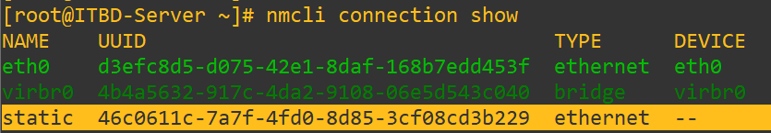
ip a s eth0
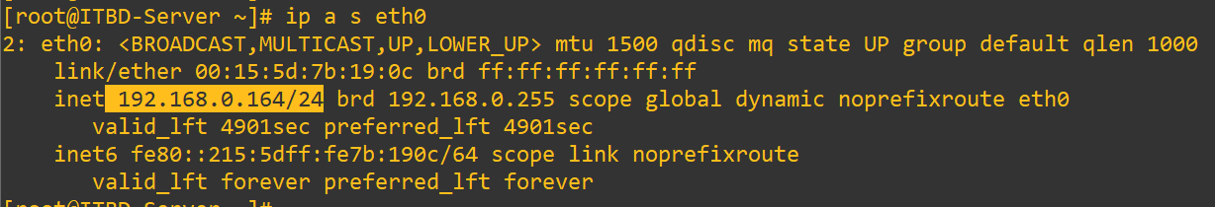
cat /etc/sysconfig/network-scripts/ifcfg-static
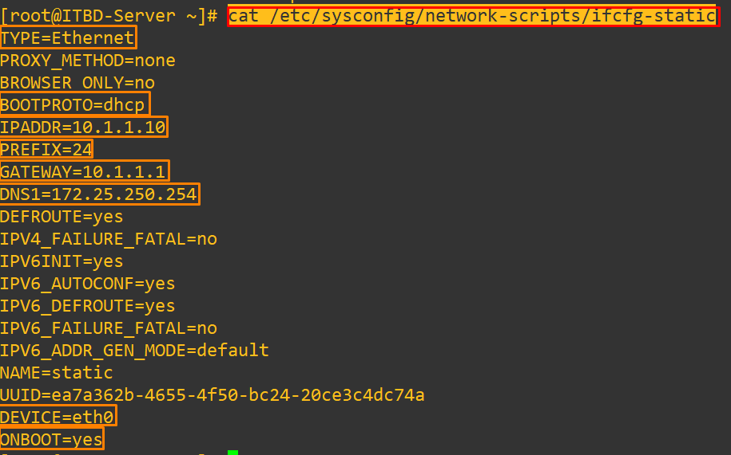
nmcli connection up static
nmcli connection show
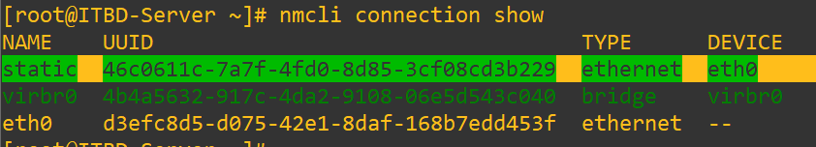
ip a s eth0
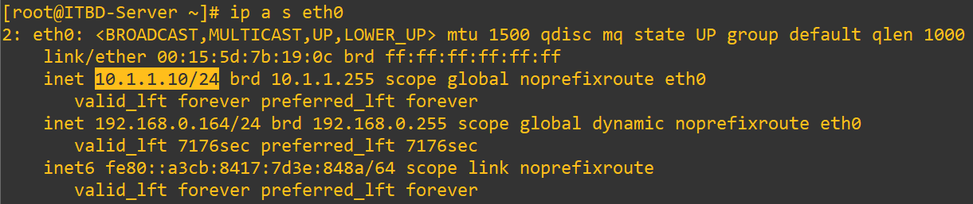

nmcli con show --active
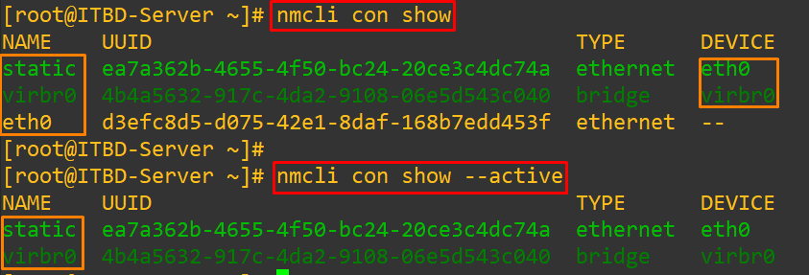

nmcli device show eth0
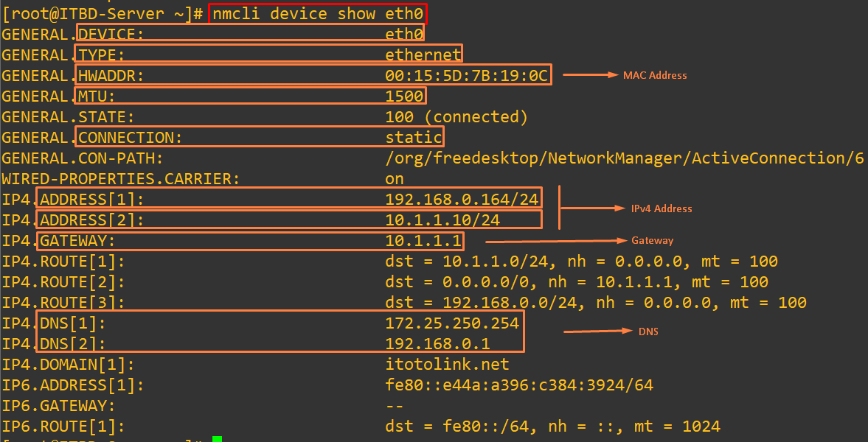
nmcli connection modify static ipv4.addresses 192.168.1.1 0/24 ipv4.gateway 192.168.1.1 ipv4.dns 8.8.8.8 ipv4.method manual && nmcli connection down static && nmcli connection up static
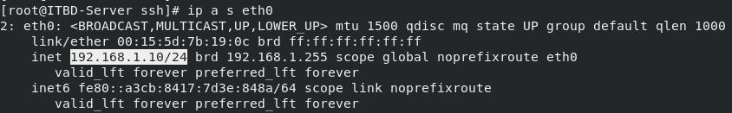
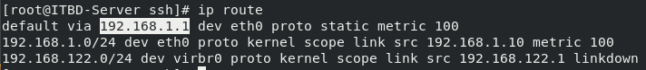

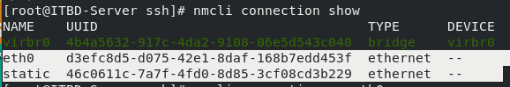

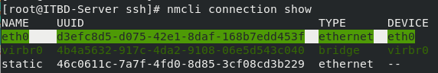

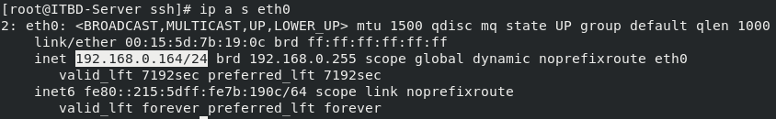

There is no ‘static’ connection in your system.
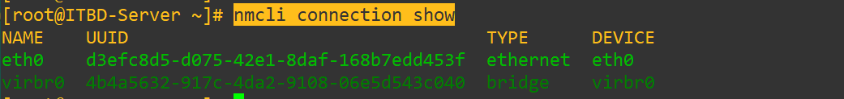
nmcli con mod "static " ipv4.dns 172.25.250.254
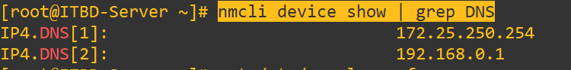
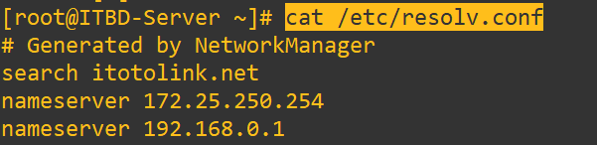

nmcli connection add type ethernet con-name "my-dhcp" ifname eth0 ipv4.method auto
nmcli connection add type pppoe con-name "my-pppoe" ifname eth0 username "your-username" password "your-password" ipv4.method auto

